34) Aim: To Draw a Deterministic Finite Automata that accepts a language L over input alphabets ∑ = {0, 1} such that L is the set of all strings starting with ’00’.

Diagram:

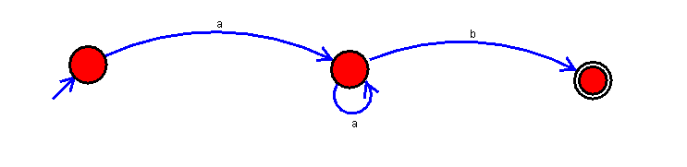

Result:

Successfully executed Deterministic Finite Automata that accepts a language L over input alphabets ∑ = {0, 1} such that L is the set of all strings starting with ’00’.